Practice Information Leaflet

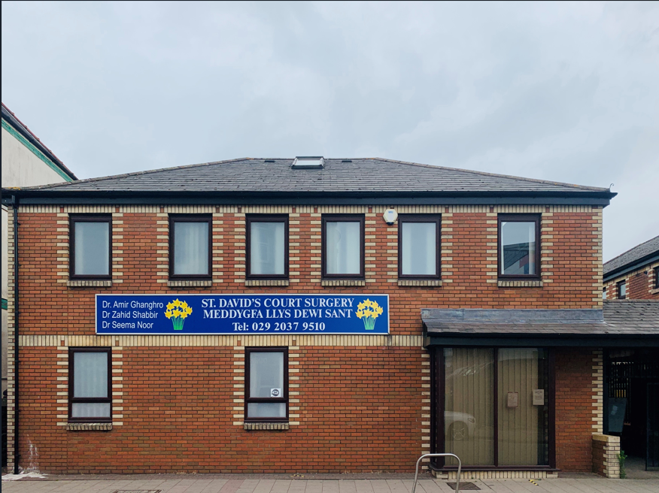

This Practice is not a limited partnership, & proud of being a teaching practice for
3rd & 5th year medical students.

The GP’s
Dr Amir Ghanghro MBBS, MRCGP (UK), FRCGP, Dip in Child Health, PGCert Diabetes
Dr Zahid Shabbir MBBS
Dr Prasanna Muthukumar MBBS Salaried GP

The Nursing Team
Kimberley Lewis ANP
Sian Lewis (Locum) ANP
Mrs Javeria Ghanghro HSCW
Mrs Aisha Afzal HSCW

The Practice also has an administration team to assist in the running of the Practice, along with attached staff such as Health Visitors, Midwives, District Nurses and a Counsellor.

Practice Area
St David’s Court - covering the geographical area of Canton, Riverside and Pontcanna. Within 1 mile radius.

Website: - Home - St. Davids Court Surgery (nhs.wales)
Surgery Opening & Appointment Times

St Davids Court
Clinic Times
Monday | 08.00 – 18.00
Tuesday | 08.00 – 18.00
Wednesday | 08.00 – 18.00
Thursday | 08.00 – 18.00
Friday | 08.00 – 18.00

Outside of these times but during the core operating hours of 08:00 – 18:30, the Primary Health Care Team provide clinical appointments and advice relating to chronic disease monitoring (assessments), child health, travel health, sexual health, health and lifestyle and minor surgery.
Out-of-Hours
Outside of these core hours, including weekends and all public bank holidays, the Cardiff and Vale University Health Board provides an Out-of-Hours Service which can be contacted on 111

How to Register
We welcome requests for registration from patients living within, or moving to, the practice area. Although registration is with the practice and not with an individual General Practitioner (GP), you may express a preference to see a particular doctor, and this will be recorded.

You can register by presenting your medical card (FP4) or by completing Form GMS1 available from reception. You will also be required to complete a Patient Information Questionnaire (PIQ) which will provide the Surgery with additional information regarding your health status. We will also ask for if available a copy of your Identification and proof of address. All newly registered patients will be invited to attend a health check.

Repeat Prescriptions
Prescriptions can be requested by handing a request slip to reception or by post to the Practice. Owing to potential errors, repeat requests will only be taken over the telephone in exceptional circumstances only and at the discretion of the GP. Alternatively, several local Chemists may also operate a prescription collection service, please ask your local pharmacy for further details. We also offer online prescription requests, please see our website or register on Wales NHS App Login screen (nhs.wales)

Please allow 48 hours’ notice for all repeat prescriptions.
Disabled Access
Entrance to the Surgery is wheelchair friendly, with an automatic door system in place, which provides controlled access and added security for safety to the Patients, Visitors and the Staff.
The toilet facilities are downstairs and are accessible by wheelchair users.

We have a clinical room and a treatment room on the ground floor, Dr Amir Ghanghro consulting room is on the First floor and to accommodate patients, when required Dr Ghanghro will utilize the treatment room on the ground floor as and when requested.

Appointments
Appointments to attend the surgeries can be made by telephoning the surgery during normal opening hours, by using online NHS Wales App or emailing requests to prescriptions.w97018@wales.nhs.uk. Routine appointments will usually be made within 2 - 3 weeks for you to see or speak to an appropriate healthcare professional. You can request your chosen clinician, but please be advised it may be a longer waiting time, than the next available appointment.

We offer on the day urgent appointments; however, we may advise you to call 999 or attend the nearest Accident & Emergency Unit.

Receptionists will ask for additional information from you to ensure you see the most appropriate health care professional and signpost to appropriate services.

Patients aged 16 – 74, who have not been seen for 3 years may request a general consultation with a doctor. Patients aged over 75, who have not been seen for 12 months, may request a general consultation with a doctor.

Home Visits
This service is at the discretion of the doctor(s) and should only be requested if you are housebound or too ill to attend the surgery. Upon a request for a home visit, the doctor will initially conduct a telephone triage call.

If you feel you require a home visit, please contact the surgery at the earliest opportunity.

Services Available
Our Practice provides General Medical Services to patients in the practice area as detailed on page 2. The Practice also provides Ante-Natal care on an appointment basis on a Thursday with set clinics from 9am and an Immunisation Baby clinic on a Thursday between 12.00 and 14:30.

Zero Tolerance
The Practice has a zero-tolerance policy towards aggressive or violent patients. Any patients found to be behaving in this manner will result in a warning and/or removal from the Practice list.

NHS Direct Wales
NHS Direct Wales is a health advice and information service available 24 hours a day, every day. You can call them on 111.

Their website also lets you learn more about your health through their A-Z encyclopaedia, and you can also search for local NHS services such as dentists, pharmacies, or support groups in your area. www.nhsdirect.wales.nhs.uk.

What We Will Do for You
We will treat all patients with courtesy and respect, regardless of their race, gender, social class, age, religion, sexual orientation or appearance, disability, or medical condition. We will respect our patients’ privacy and confidentiality at all times, ensure our premises are welcoming, easy for patients to find their way around and appropriate to the needs of users, including the disabled. All members of the primary care team are dedicated to provide a health service which meets our patient’s needs.

What You Can Do for Us
Be courteous and polite to staff at all times. Endeavour to attend appointments / surgery at the correct time. Give us at least 24 hours’ notice when cancelling a booked appointment to enable it to be utilised by another patient. Ensure that you complete a change of details form if you or your family change address or contact telephone numbers.

Patients Records
Your hard records about your health and any treatment or care you receive from the NHS are kept securely on site with the NHS Registrations department. Your information will either be written down (manual records) or held on computer (electronic records) at the practice. These records are then used to guide and manage the care you receive and as such are accessed by appropriate members of practice staff. This information will be handled in the strictest of confidence and will be subject to the principles of confidentiality GDPR rules.

Comments / Complaints / Suggestions
The Practice Manager is responsible for the administration and operation of the Practice. She is happy to receive any complaints, compliments, or suggestions you have regarding the services offered by the Practice. These can be provided in a letter or an email, and on occasions, verbally by telephone or in person by appointment.

Christine Brown – Senior Practice Manager. Jennifer Tilley – Practice Manager practice.manager.w9018@wales.nhs.uk

Or direct to NHS Wales complaints and concerns: Putting Things Right | GOV.WALES. You also can contact the Local Health Board by completing the online form on their website Concerns and complaints - Cardiff and Vale University Health Board (nhs.wales)

University Health Board

Further details of Primary Medical Services in the area can be obtained from the Cardiff and Vale UHB Primary Care Team based in the PCIC Offices, Woodland House, Maes y Coed Road, Cardiff. CF14 4HH. Telephone : 02921 836123

